English  In English this term, we will be learning how to write persuasive texts using persuasive techniques inspired by The Adventures of Fredrick. We will also be writing narratives inspired by The Boy in the Tower and then studying poetry.  In guided reading, we will be reading Shakespeare’s ‘A Midsummer Night’s Dream’, ‘Five children and it’ and ‘I am not a label’. |  | PE  Our PE lessons are on Wednesday and Thursday.  Children need to come into school in their full PE kit.  We will be learning how to play tennis, netball, dodge ball and tag rugby. |  | Maths  We will be problem solving all four operations, fractions and percentages. Identifying unknown angles and area.  We will be recapping place value throughout the term.
Science  Forces  Gravity, friction, air resistance and how this affects our solar system.  Earth and Space  The moon, Earth’s rotation and how this impacts the seasons. |  | 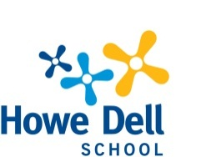  Spring Term  Year 5  Welcome to our Spring Term Curriculum Flyer, showing an overview of our learning this term. Please use this information to support a discussion of learning with your child at home. If you have any concerns please contact us:  year5@howedell.herts.sch.uk |  | Computing  Programming: selection in quizzes  Data and information: using Flat File Databases
PSHE  · Citizenship: This unit helps pupils understand key aspects of law, rights, and civic responsibility  Economic wellbeing: This unit helps pupils understand key financial and career concepts. |  |  |  | RE  Sikhism - Beliefs and moral values Christianity - Salvation
History/Geography  Geography – We will be looking at map work and grid references.  History – Ancient Greeks  Comparison study of Maya and Anglo Saxons |  | Music  The Fresh Prince of Bel-Air Style: Old-school Hip-Hop  MFL  Saying and writing about our class and a tea room. |  | Art /D&T  Art – Textiles and collages, creating a wall hanging  3D work creating slab and coil pots  D&T – Textiles - Which fabric is ideal for creating a functional and hardwearing lunch bag?  Mechanisms – design and make products that use pulleys and gears to lift loads.

Home Learning  Home Learning will be sent out weekly on a Thursday and is due in the following Thursday.  Home Learning will be set using Google Classroom. These will focus on the topics we are studying in our wider curriculum.  Children should read every day and be listened to, wherever possible. Please add your comments to the Reading Diaries when necessary.  Children should also practise their multiplication tables on a regular basis: using TTRS for approximately 10 minutes at least five times per week will help. |  | Online Links  https://play.ttrockstars.com/auth/school/student  https://www.mymaths.co.uk/  https://www.curriculumvisions.com/  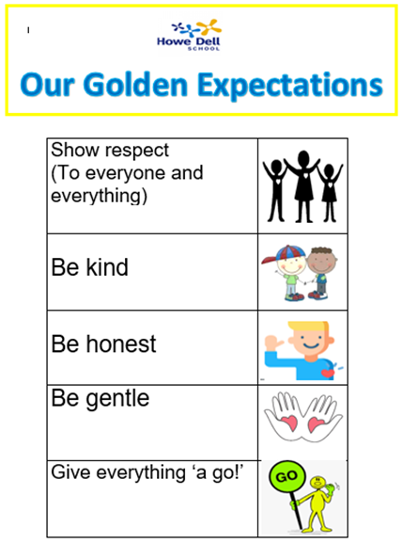
e-Safety

Please ensure that any children who are using a device that is connected to the internet are supervised. Talk to your children about staying safe online and visit our school website for more information. Age-limit information has already been provided.
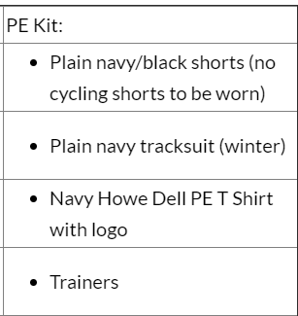
PE Kit

Children should come to school wearing their PE kit on Wednesday and Thursday.

