

Mindfulness menu

What is mindfulness?

Mindfulness means paying full attention to something. It means slowing down to really notice what you are doing.

Why is being mindful good for us?

Mindfulness helps us to:
- focus better
- stay calm under stress
- not get too upset about things
- slow down instead of rush
- listen better to others
- be more patient
- get along better with others
- feel happier and to enjoy things more

Source:
(Kids Health from Nemours 2017,Mindfulness,The Nemours foundation, viewed 3 May 2020, https://kidshealth.org/en/kids/mindfulness.html)

Want to give it a try?

Every week you can try 3 new activities from the mindfulness menu below:
- Look at the clouds   | Set a timer for 15 minutes. Lie down on a blanket on the ground and look up at the clouds in the sky. How do the shapes change as they move with the wind? After the 15 minutes have passed try to draw or write down what you saw.
- Hug a tree  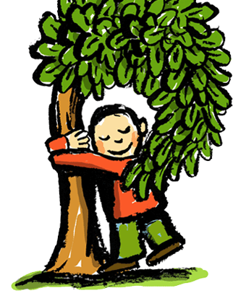 | Look for a medium-sized tree in your garden, park or forest near you. Wrap your arms around the trunk and lean your head against it. Try to become one with the tree.  - Is it moving with the wind?  - Is it making any sounds?  - What does it smell like?  If you want to you could try and repeat this activity with a few different trees.
- Make a nature mandala  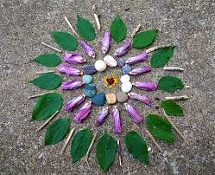 | Collect some natural materials, for example rocks, sticks, leaves, shells and flowers. Decide where to make your mandala. Choose a centerpiece that you would like to place in the middle of your design. Use the other objects to create rings around the centerpiece. Repeating patterns create a very beautiful effect.

- Go for a listening walk   | Go for a walk in your garden/nearby park or just around your neighborhood. Try to be very quiet and listen carefully to all the sounds around you. After the time is up, think about what you have heard and where the sounds may have come from.  You could also try to do this listening exercise whilst lying down on the ground with your eyes closed.  Click on the link below to download a worksheet you can use to draw and write about what you have heard during your walk.  https://www.teacherspayteachers.com/Product/Listening-Walk-Worksheet-1488704
- Make a calm down jar  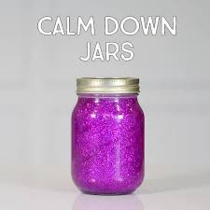 | Making a calm down jar is a good way to help you calm down when you feel angry, stressed or worried. When you have some of these feelings you can grab your jar, give it a shake and watch the glitter swirl and float around. This will give you some time to calm down and to think about your feelings.  Click on the link below for step by step instructions and video on how to make a calm down jar  https://www.goodtoknow.co.uk/family/things-to-do/glitter-jars-how-to-calm-down-jar-105300

- Build with lego    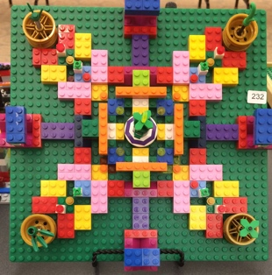 | Take some time to build something with your Lego. It has been proven that building with blocks or models allow your brain to “switch off”, so get building!  Tip:  You could try to build a mandala pattern using Lego and a base board.
- Make a worry eater  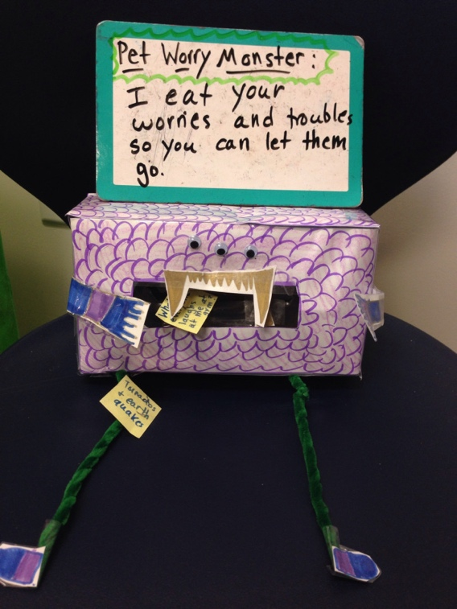  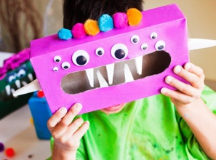 | To make your very own worry eater you will need:  - An empty tissue box  - Googly eyes, but you can also make your own eyes from white paper.  - Glue  - Bits of paper for teeth  - Poster paint (any colour)  How to make your worry eater:  1. Paint your empty tissue box and leave it to dry.  2. Once your box is dry, stick on as many eyes as you would like.  3. Cut some triangular shapes for teeth. Stick them around the edges of the opening on the front side of the box.  Your worry monster is now ready to be used.  How to use your worry eater:  Write or draw pictures of things that you feel worried about and put them into your worry eater’s mouth. The worry eater will look after you worries, so you don’t have to.  Maybe you could share your worries with your mummy or daddy as they might be able to give you good advice that could help to make your worry smaller or even take it away completely.

- Balloon adventure   | Click on the link below to listen to a mindfulness video. Follow the instructions carefully. Afterwards you should feel calm and relaxed. Enjoy!!  https://www.youtube.com/watch?v=ZBnPlqQFPKs
- Kitchen-roll Art  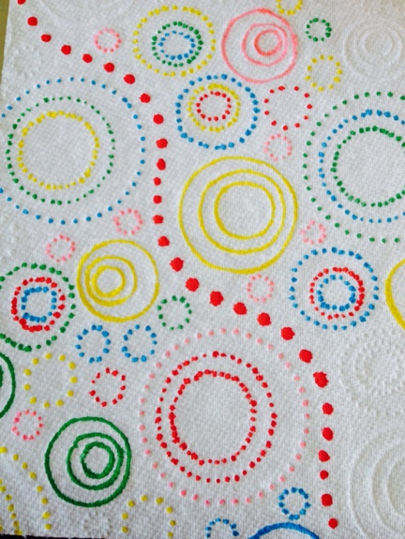 | Mindfulness is all about slowing down and focusing on something calming. Colouring-in the patterns on kitchen-roll, toilet paper or paper towels can be very relaxing as you don’t have to worry about what to draw, just making marks on the paper!
- Spidey-Senses   | This is a mindfulness exercise you can do anywhere, any time. Take a few minutes to stop and use your “Spidey-Senses.”  Think about the following:  What can you see?  What can you smell?  What can you hear?  What can you touch?  What can you taste?  You will become really focused when doing this and will notice small details around you. You are being mindful!
- Breathing and bubble blowing   | Grab your bubble pot and wand and find a quiet space on your balcony or in your garden. Take a deep breath in before you blow and a long, slow breath when blowing out.  Think about and listen to your breathing every time. Watch the bubbles as they float up into the sky. Use your “Spidey senses” and think about what you can see, smell, hear and touch. Start again taking a deep breath in and a long breath out. Repeat a few times until you feel calm and relaxed.
- Body Scan   | Lay on your back on a comfortable surface and close your eyes.  Squeeze every muscle in your body as tight as you can – squish your toes and feet, squeeze your hands into fists and make your legs and arms as hard as stone. Hold for 5-10 seconds.  Now, release all your muscles and relax for a few minutes. Think about how your body is feeling now – are you more relaxed, calmer?  Repeat several times.
- Put your Worry in the Waiting Room!    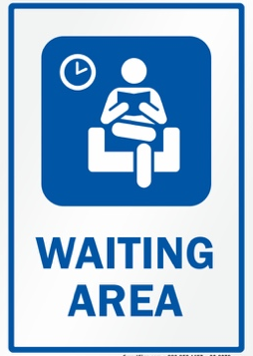 | Sometimes worries can keep coming into our heads without us consciously wanting them to. This can be really annoying, and tiring!  One way to help is to imagine putting your worry in a ‘waiting room’ and making an appointment to ‘listen’ to it later on.  Decide on a time, place and length of time for ‘listening’ to your worry (for example, after dinner, my bedroom, 15 minutes) you can even write the appointment down if you want to. Then focus on the activities of your day – do something enjoyable or another mindfulness activity to help you let go of the worry until your appointment time.  When it is time to listen to your worry, ask yourself:  Does this worry still seem so big? Is it still bothering me?  If it is, it can help to write your worry down, draw a picture to represent it or talk it through with a family member or friend . Remember, however, that you are only thinking about this worry for the agreed amount of time, after which you can put it back in the ‘waiting room’ until the next day.  If you find that your worries will not ‘wait’ or go away, then it is very important that you ask an adult for help.
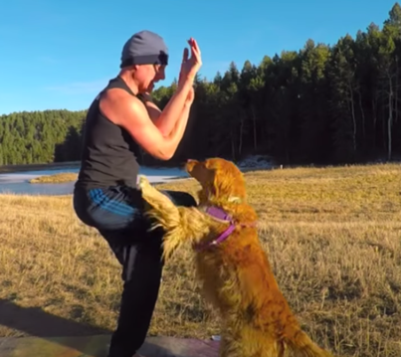  - Yoga for Tweens | Yoga is one of the best mindfulness activities you can do as it relaxes both your body and your mind. If you need something a little more grown up than Cosmic Kids, then try one of Sean Vigue’s 20-minute yoga classes. There’s a great dog, a pretty cool backdrop of the Colorado Rockies and not a unicorn in sight….  https://www.youtube.com/watch?v=7SFGaQiYJ78
- 3 Minute Music   | Mindfully listening to a music track is a quick and effective stress reliever and a great way to practice being completely in the moment.  Choose a song to listen to – instead of just paying attention to the words, ask yourself:  What instruments do you hear? Is the song loud or soft, fast or slow?  What emotions does the song create in you?  Where in your body do you feel them? Can you feel the beat of the music in your body?
- Garden yoga  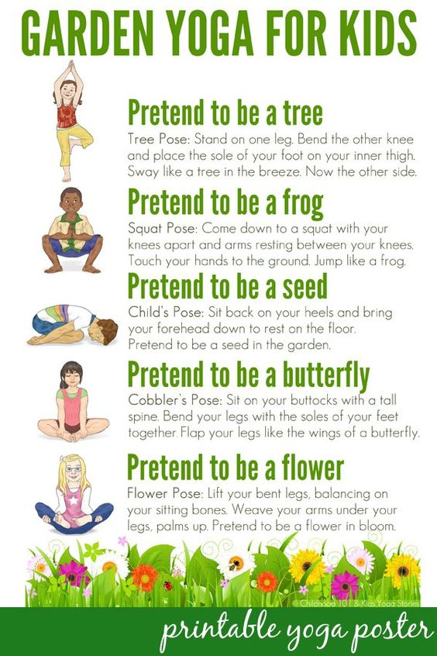 | Choose a quiet spot on your balcony or in your garden. Take a few minutes to choose a few of the garden yoga poses from the poster. Try and remain in each pose for three minutes concentrating on being calm and listening to your breathing. Closing your eyes when in the poses might help to lessen distractions around you. You should feel relaxed and happy when you are done. Click on the link below for a bigger version of the poster.  https://childhood101.com/yoga-for-kids-a-walk-through-the-garden/
- Mindfulness doodling  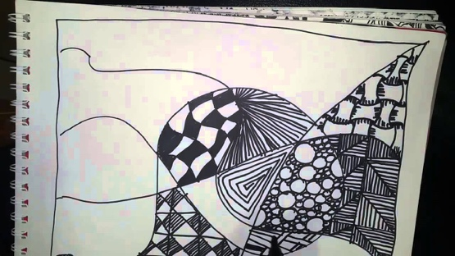  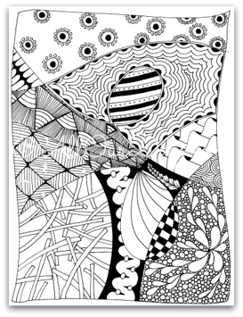 | Take a piece of A4 paper. Draw some squiggles and lines covering the page. You can use one colour or a variety of colours if you would like. You will notice that you have created smaller shapes where your squiggles and lines overlap. Draw patterns and shapes to fill up the smaller sections on your page. Use your Spidey-senses and think about:  - What you can hear  - What you can smell  - What you can feel  Try not to rub out and let your drawing flow without stopping too much.  Watch the video below for inspiration  https://www.youtube.com/watch?v=pVm_DL3YEXI
- Create your own Zen garden  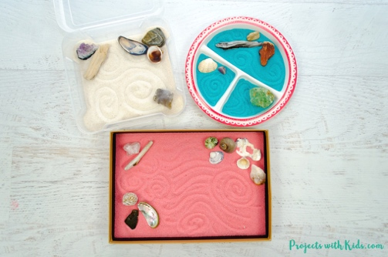  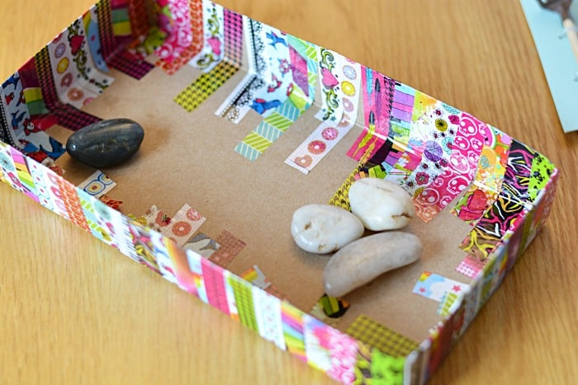 | Make your own Zen garden by pouring some sand into an empty shoe box lid or any other shallow container. Add some natural materials like pebbles, plants and a little bowl for a water feature. Take out your Zen garden when you are in need of a quiet and relaxing activity. You can use a fork to draw some mindfulness doodles in the sand of your garden.  Click on the link below for more detailed instructions on how to create your very own Zen garden:  https://www.sunnydayfamily.com/2017/05/zen-garden-for-kids.html

